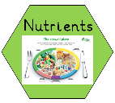
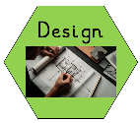
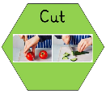
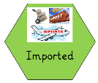
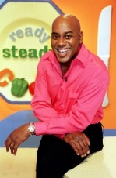
- Designers and inventors- Biographical Knowledge
TWAL: We will learn about a famous chef and how they link to our design brief.
What do I know about Ainsley Harriott?
We will work in small groups to research Ainsley Harriott. We will build on the biography kills we learned in year 1 to create a group fact sheet about Ainsley Harriot.
Biography - Ainsley Harriott (ainsley-harriott.com)
We will be given our design brief- to make no cook hoisin Spring Rolls
No-Need-To-Cook Hoisin Spring Rolls - Ainsley Harriott (ainsley-harriott.com)
Glossary
Fruit – plant or tree’s edible seed with envelope.
Vegetable – plant used for food.
Nutrients – all the things in food that the body needs to remain healthy.
Sensory evaluation – subjective testing of foods where senses are used to evaluate qualities such as appearance, smell, taste, texture (mouth feel).
Cross Curricular Links – PE – Keeping healthy PSED – Positive mental health Science – balanced diet
Meet a famous chef:

Ainsley Harriott MBE is an English chef and television presenter. He is known for his BBC cooking game shows Can't Cook, Won't Cook and Ready Steady Cook. He is also a best-selling author and has sold over two million books worldwide.

Words you will know:

Skills you will use:
shape, mix and stir,
spoon ingredients into another container,
measure ingredients, and cut ingredients.
Prior Learning: In Year 1 children will have learnt how to : juice, peel, mix and stir, spoon ingredients into another container, measure ingredients, and cut ingredients

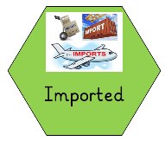
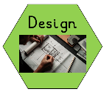
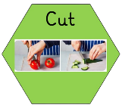
2. Generating Ideas: Looking and talking
We will look at the no cook recipe for Hoisin Spring Rolls No-Need-To-Cook Hoisin Spring Rolls - Ainsley Harriott (ainsley-harriott.com) and discuss the ingredients. We will look at some shop brought spring rolls and see how they are shaped and formed. What skills will we
need? We will look at the ingredients in the shop brought spring rolls and compare
them with Ainsley Harriet’s recipe. We will learn that some of the ingredients are
imported.

3. Generating Ideas: Experimenting
We will experiment with rice paper to understand its properties what we need
to do to it to make it roll.
We will practice cutting different ingredients using the claw grip and bridge method
to cut.
We will explore different ingredients that we can include in our spring rolls- bean sprouts, sugar snap peas, peppers. We will discuss which ingredients we could change to meet cultural and dietary needs.

5. Making Food: Materials and techniques
TWAL: to adapt a simple recipe with adult support
What tools and food processing skills will I use?
What order will I work in?
What support will I need?

4. Generating Ideas- Making a proposal

We will design our own spring roll based on Ainsley Harriet’s no cook spring rolls.
We will identify what skills we need to use to be able to make the spring rolls.

shape, mix and stir, spoon ingredients into another container, measure ingredients, and cut ingredients.

6. Evaluating
Use of techniques
The product
Identify similarities and differences to others’ work
Reflecting
Do I need to adjust or change anything?

