


Theme: Our European neighbours: As a tourist which coastal capital city would you visit and why?
Concept: Location, Human and Physical Features, Settlement, Mapping, Weather and Climate
We are learning about some different coastal cities in Europe. We will use a variety of maps to investigate, identify and compare their location, human and physical features.

4. What similar places could tourists visit?
TWAL: To find out and identify similarities of the human features of other European Cities.
In groups, we will look at digital maps we will record common human features such as zoo, museums, harbours/docks/piers and churches. We will share our findings with the class.
Some European capital cities have similar human features.

5. What are the different human features of other European cities? What do tourists visit?
TWAL: To find out and identify differences between the human features of other European Cities.
In groups, we will use maps, photos and aerial maps to identify some unique human features of Dublin, Lisbon, Reykjavik and Baku. We will share our findings with the class.
Each capital city has some unique human features.

3. What physical features would I see in other European capital cities?
TWAL: To name and locate topographical features of some capital cities.
In groups, we will look at maps and aerial photographs we will identify lakes, rivers, islands, hills, mountains in Dublin, Lisbon, Reykjavik and Baku and areas of high land in other European countries. We will share our findings with the class.
Capital cities may have similar and different physical features. Dublin, Lisbon, Reykjavik and Baku are all coatal capital cities.

6. If I was a tourist where would I go?
TWAL: To write a short report saying where I would go and why.
We will use all the information we have gathered to discuss the theme’s question. We will share our ideas and opinions by writing a short report.

A tourist is someone travelling and visiting a place for pleasure.
Tourism is travelling for pleasure.

Where are some other European capital cities?
TWAL: To name and locate some capital cities of European countries.
We will recap the location of the city of Southampton and our capital city, London, in the UK and its location in Europe. We will recap the location of Europe as a continent. Using atlases and maps we will find and compare the locations of the following capital cites and their countries: Dublin, Lisbon, Reykjavik and Baku.
 Dublin, Lisbon, Reykjavik and Baku are European capital cities.

2. What weather would I experience in other European capital cities?
TWAL: To find out about some capital cities climate and create a simple climate map.
In groups, we will use digital climate maps and tables showing weather averages to compare the climate of Dublin, Lisbon, Reykjavik and Baku. We will compare their climates in relation to the equator. We will share our findings with the class.
Countries nearer the equator experience higher temperatures. Weather further away and closer to the poles is colder.

Words we will know!

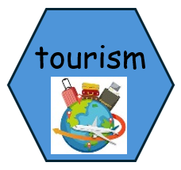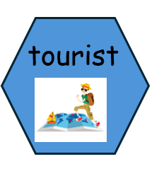
Prior Learning:

