
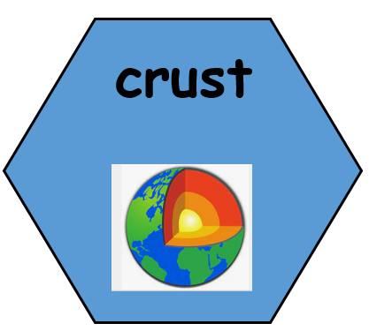
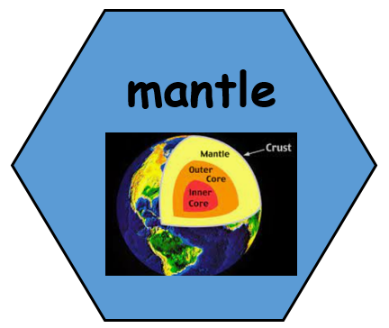
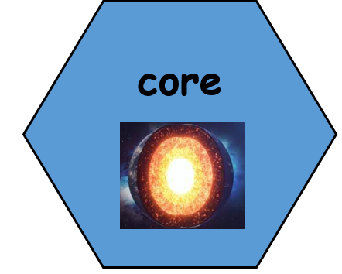


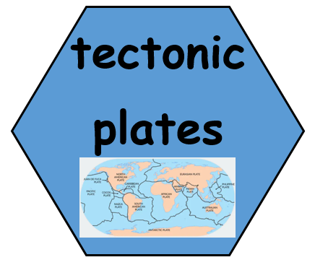

7. What damage has been caused?
TWAL: To find understand and describe the key features of earthquakes and tsunamis, and their impact.
We will look at a case study of an earthquake. We will also learn about the causes of a tsunami. Children will talk about the impact of earthquakes and tsunamis on a settlement.
A tsunami is a giant wave that can be caused by earthquakes, volcanic eruptions, or landslides under the ocean

6. What is an earthquake?

TWAL: To find understand and describe the key features of earthquakes

We will going learn about why tectonic plates move, what an earthquake is and why they occur. Using Real-time Earthquake maps we will look tectonic plates and the location of earthquakes near to Aomori.

An earthquake is a sudden release of energy in the Earth's crust that causes the ground to shake. Earthquakes happen when tectonic plates move, causing friction or pressure to build up.

5. Where in the world is Aomori and what it it like?
TWAL: To use maps to describe Aomori’s location, its physical and topographical features.
Using maps and atlases we will locate Aomori: what country, continent & hemisphere it is in as well as its position in relation to the equator. Using the keys on a map we will identify, investigate and describe some physical and topographical features.

Words we will know!

The Earth's inner core is a huge metal ball,. Made mainly of iron and is very very hot.
Tectonic plates are massive slabs of solid rock that fit together to make up the Earth's crust.
The crust is the outermost major layer of the Earth.
The layer of Earth between the crust and the outer core. The mantle is hot and dense.

2. What is a volcano and what causes a volcano to erupt?
TWAL: To find understand and describe the key features of volcanos.
We will locate Mount Vesuvius on a map, learn and explain the causes of a volcanic erupting including a basic understanding of the earth, the plates (broken crust) boundaries (where plates meet), and convection currents (the causes of plate movement).
Volcanoes erupt when gas bubbles in the magma expand, building up pressure that forces magma through weak spots in the Earth's crust

Where in the world is Naples and what is it like?
TWAL: To use maps to describe Naple’s location, its physical and topographical features.
Using maps and atlases we will locate Naples: what country, continent & hemisphere it is in as well as its position in relation to the equator. Using the keys on a map we will identify, investigate and describe some physical and topographical features.

Theme: Which coastal city is the riskiest to visit?
Concept: Location and Place, Mapping, Human and Physical Features
We are learning about volcanoes and earthquakes, what they are, how they are caused and their impact on settlements. We will use case studies, maps and conduct a simple experiment to help us.

3&4. What damage has been caused? What erupts from a volcano?
TWAL: To find understand and describe the key features of volcanos, and their impact.
Chn to make an accurate volcano model of Vesuvius including human and physical features in the surrounding area, e.g. sea, ocean, settlements, mountains, roads or the plates and processes happening within the crust and mantle. Chn learn about the material that can erupt from a volcano. Children will talk about the impact of an eruption on a settlement.
When a volcano erupts, it releases a mixture of molten rock, gases, and rock fragments

Prior Learning: Y2 Children learnt the names of the continents and about the equator. Y3 children key word: topographical. Y4 A2 children described the human and physical features of other locations using maps.

